Keystone Economy100 Alfalfa

Keystone Economy100 brand alfalfa is an exceptional forage yielding, persistent alfalfa. It is a good value with excellent seed quality. Keystone Economy100 performs best in high producing, well-drained soils

Agronomic Summary
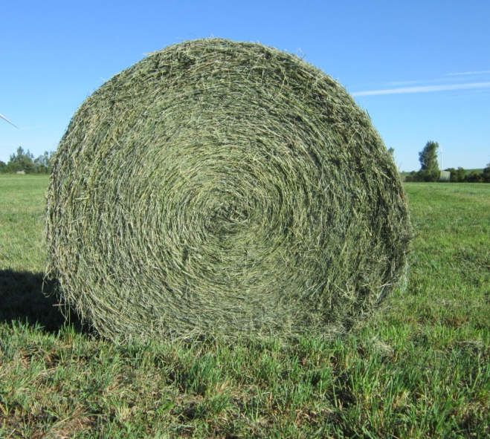
Disease
Bacterial Wilt HR
Fusarium Wilt HR
Phytophthora Root Rot HR
Anthracnose (Race 1) R
Aphanomyces Root Rot (Race 1) MR
Verticillium Wilt MR
DRI 25

Agronomic Traits
Fall Dormancy 4.0
Winter Survival 2.2
Root type Tap
Crown Depth Average

