Ultra 358PLH Alfalfa

Ultra 358PLH brand expresses tolerance to potato leaf hopper infestations. It is a winter hardy, good forage yield variety with exceptional forage quality characteristics. Ultra 358PLH seed can be sold untreated for organic forage production. When potato leaf hopper infestations become severe, spraying may be necessary.

Agronomic Traits

Bacterial Wilt HR Potato leaf hopper HR
Fusarium Wilt HR Winter Survival Index 2.7
Phytophthora Root Rot HR Fall Dormancy 3.5
Anthracnose (Race 1) HR Cutting Recovery 7.2*
Aphanomyces root rot R Forage Yield Level 7.5*
Verticillium wilt HR Forage Quality 7.9*
DRI 29 Wheel Traffic 7.3*
*: 1-10, 10 is best

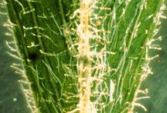
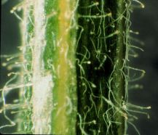

Glandular hairs on the alfalfa petioles and stems.

